# CREATE IBM WATSON IOT PLATFORM AND DEVICE

# IBM-Project-27598-1660060762

# **Team Leader : Dheepakraj P**

# **Team Member : Dhachayani K**

# **Team Member : Divi Sushma**

# **Team Member : Srinivasa Reddy D**

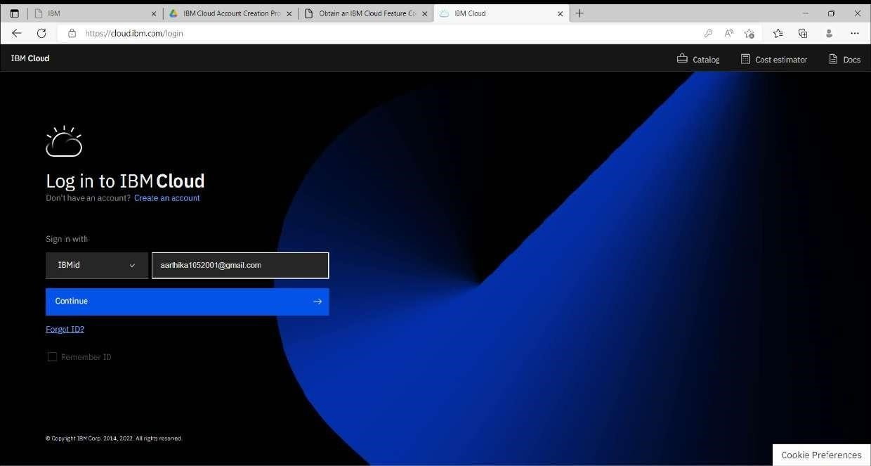

To create the IBM Watson IOT platform and device

# STEP1: create an IBM cloud account with the individual IBM id and password

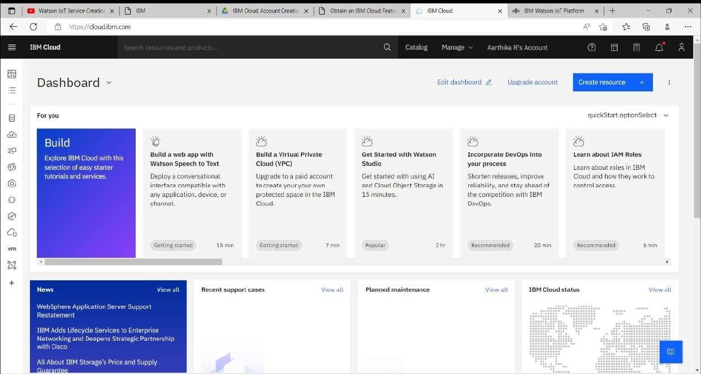

STEP2: Home page of IBM cloud

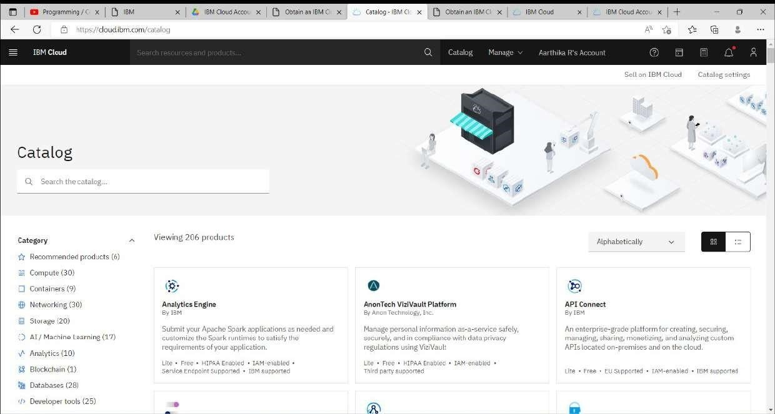

STEP3:Click on the catalog on the top

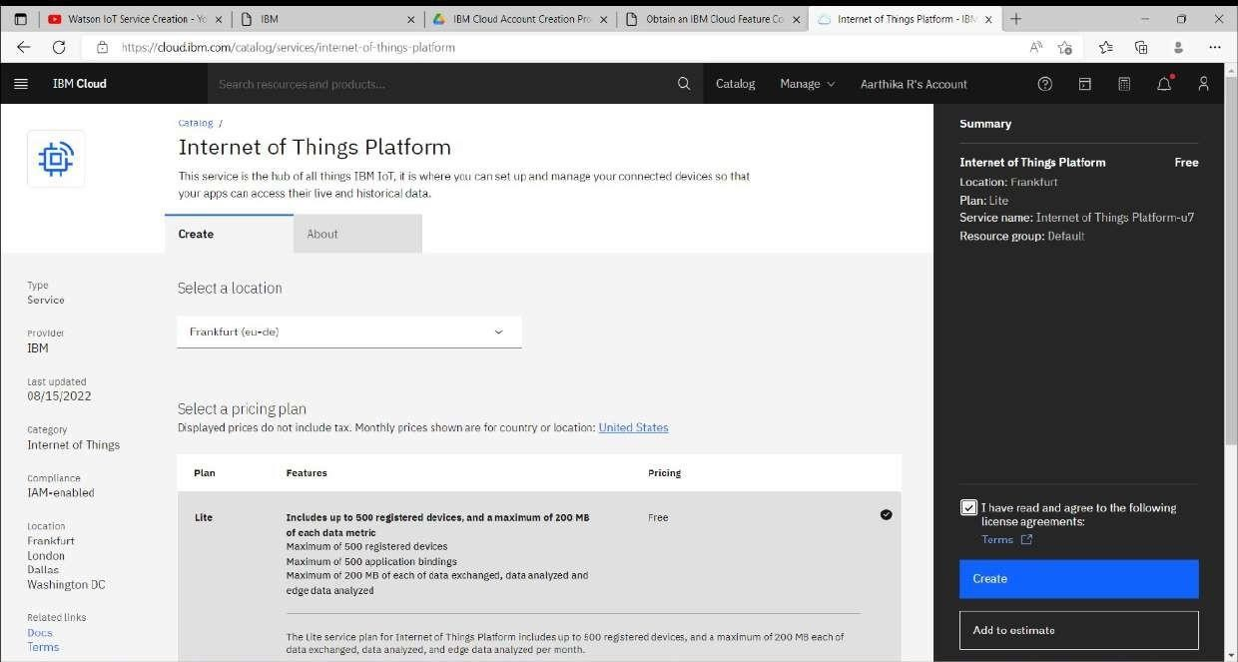

STEP4:Click on IOT in the category mentioned

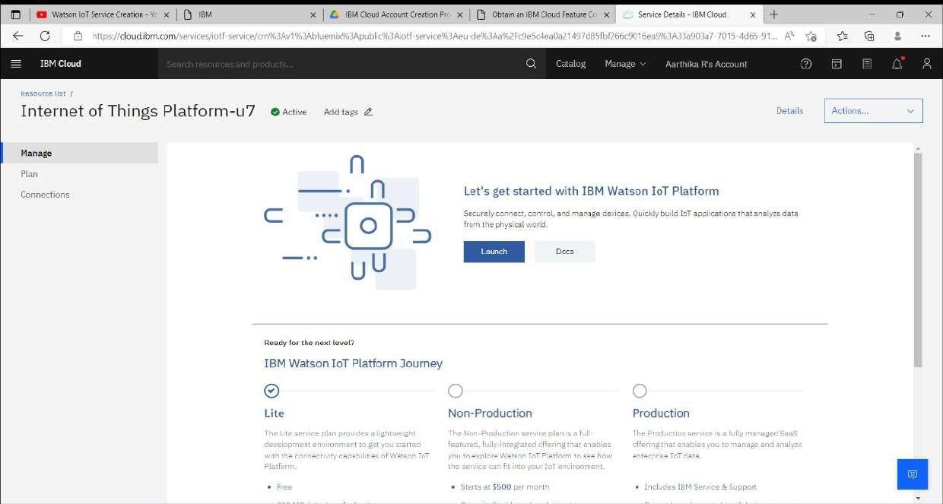 STEP5: Internet of Things Platform Child_safety will be created, when there are different options like Manage, plan, and connection

STEP6: Click on the launch button in the manage tab, it will cloud to create a device

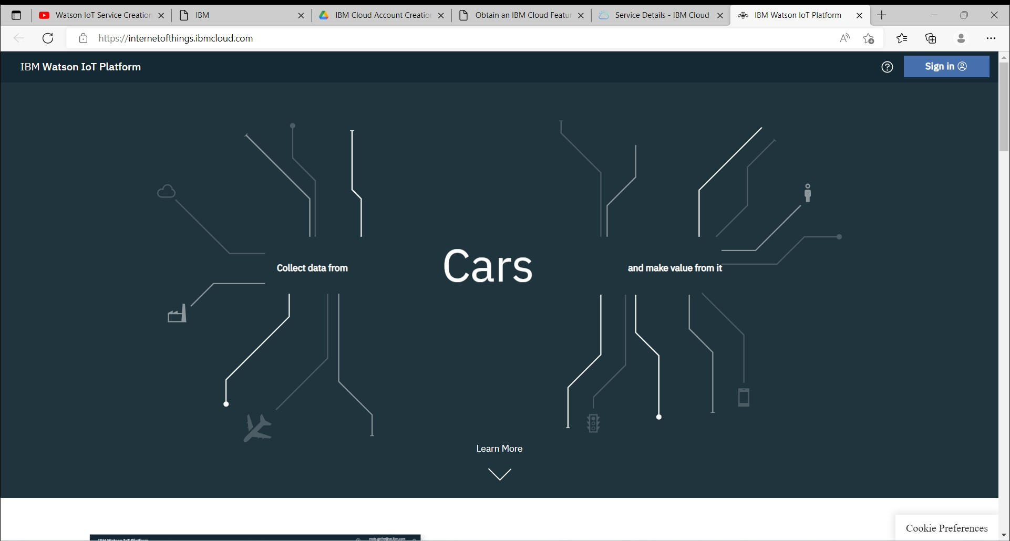7

STEP7: Enter the details to sign in to the Watson Cloud to create a device

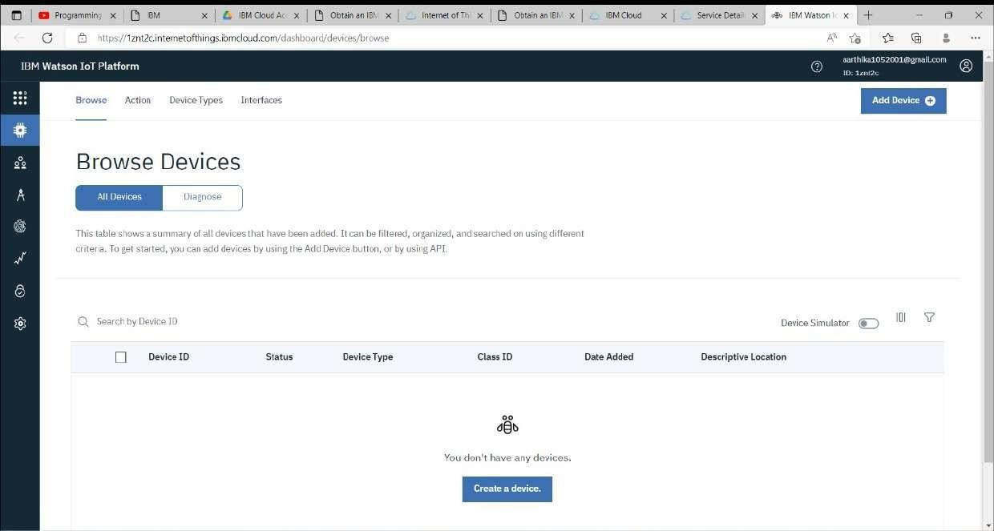

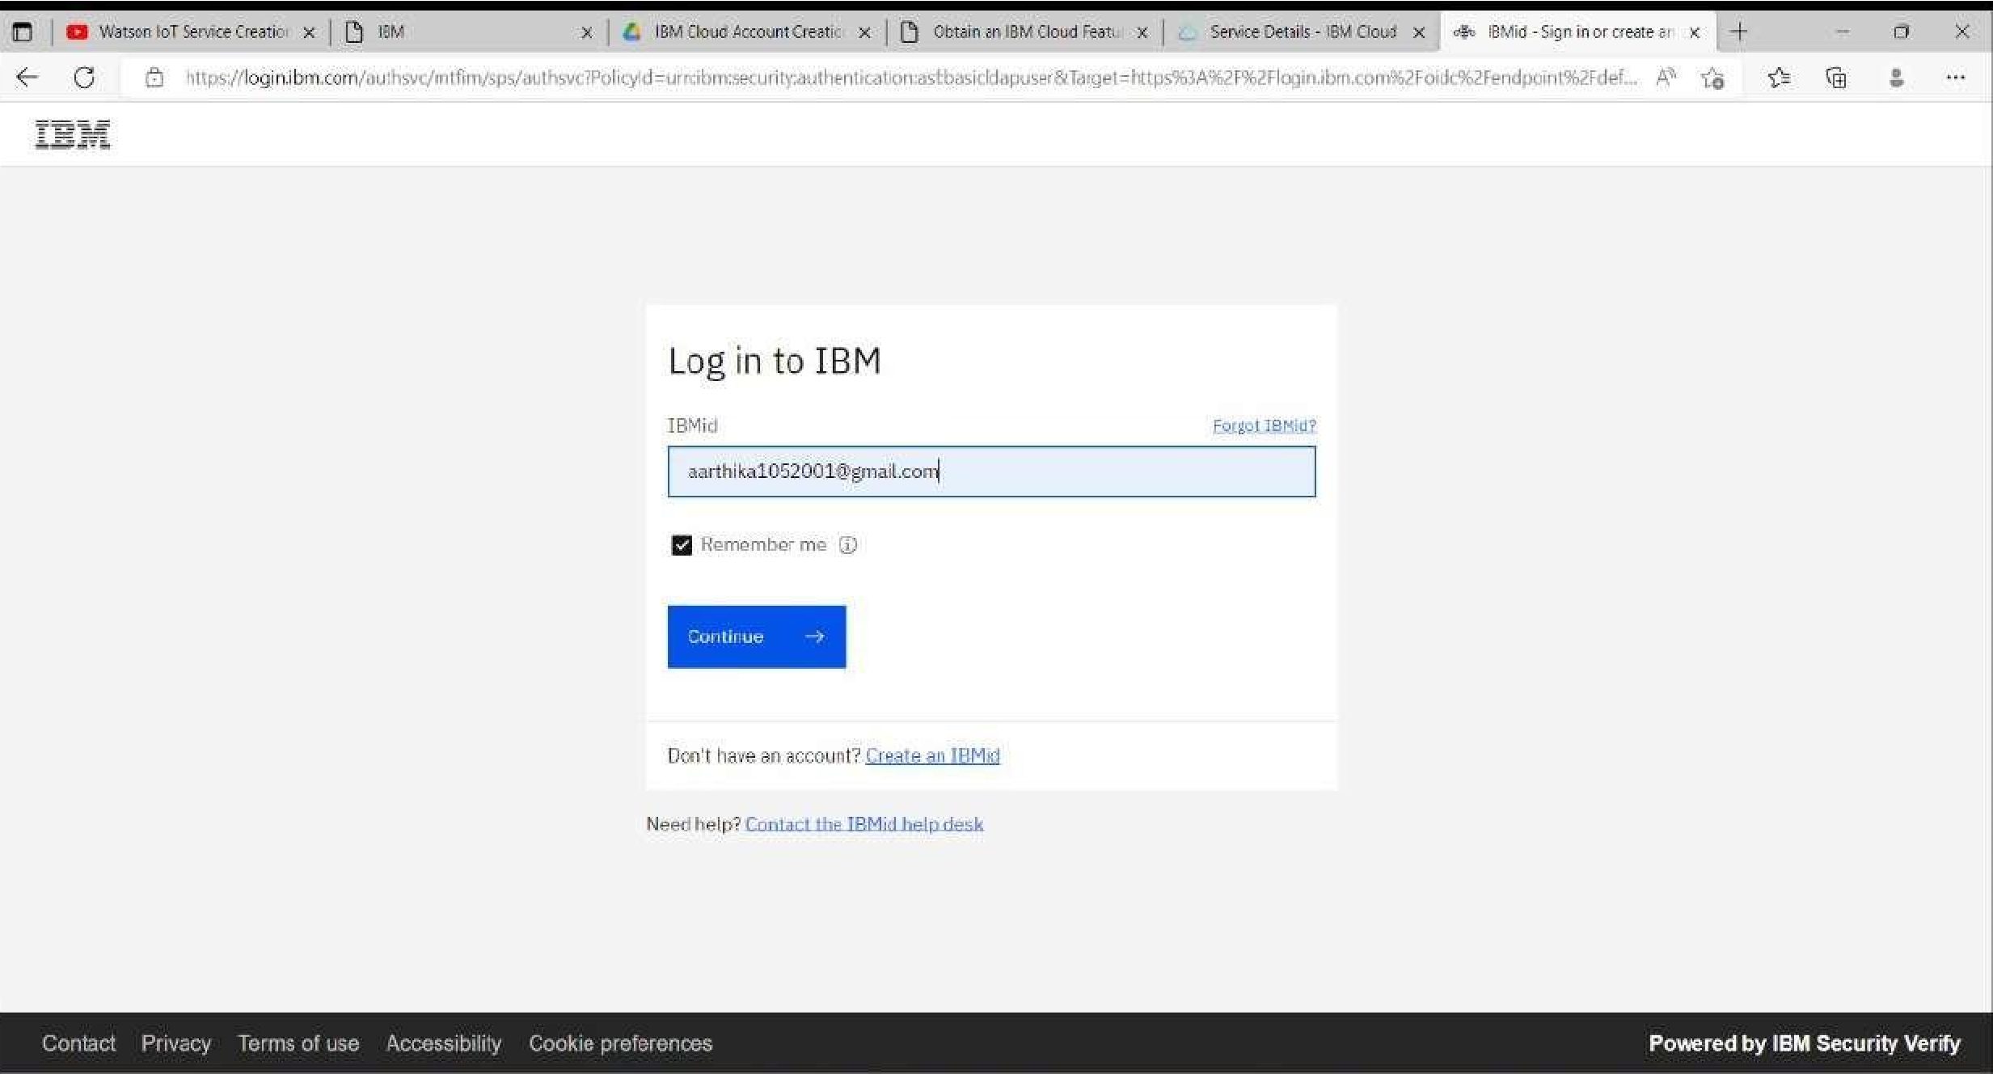

STEP8: And again clicking on the launch button will open this tab, the device will help in the creation Of the devices, the addition of devices, and the display of details of the devices.

STEP9: The setting tab is used to change the general setting if needed for the project

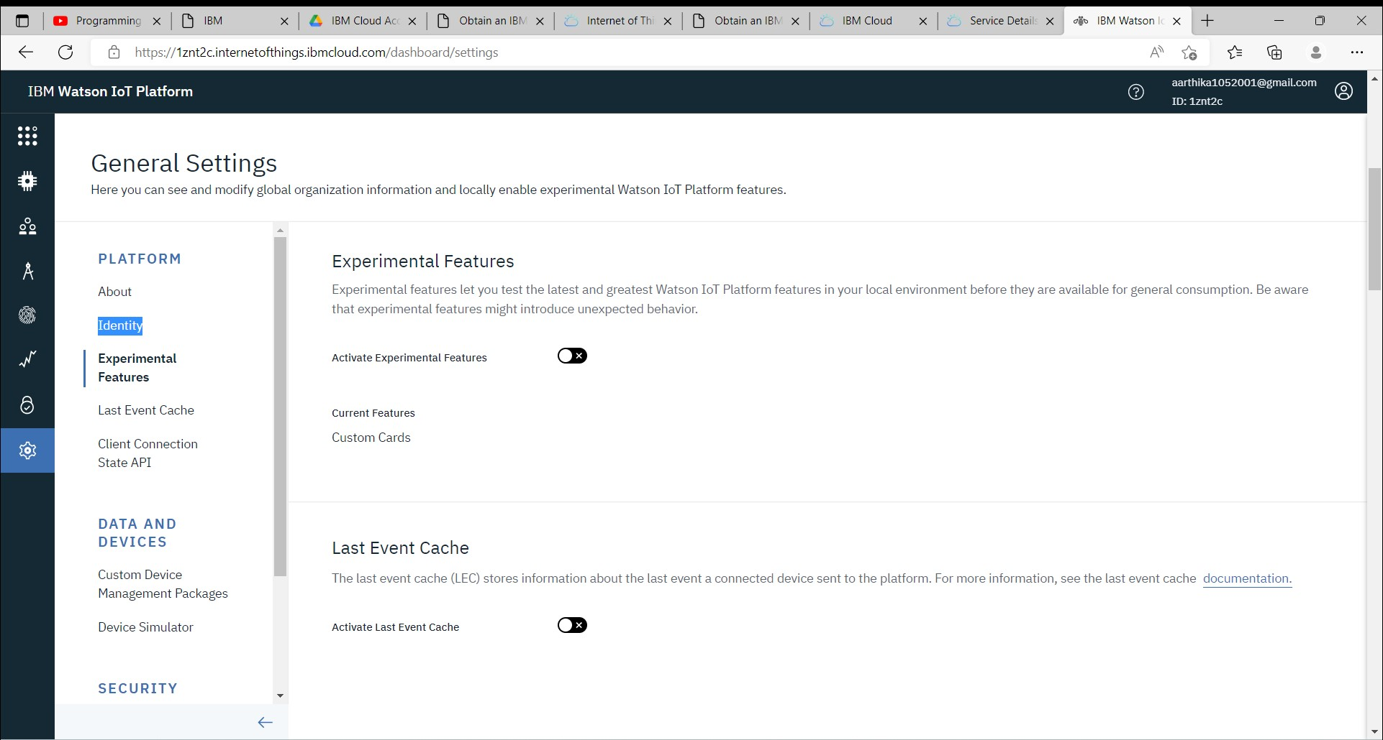

STEP10: In the security tab we can choose the type of security connection and can change according to specification

# STEP11: Usage gives the summary of how many bytes are used between the devices and the IBM cloud

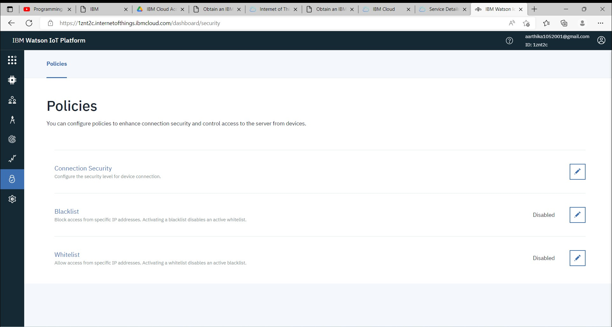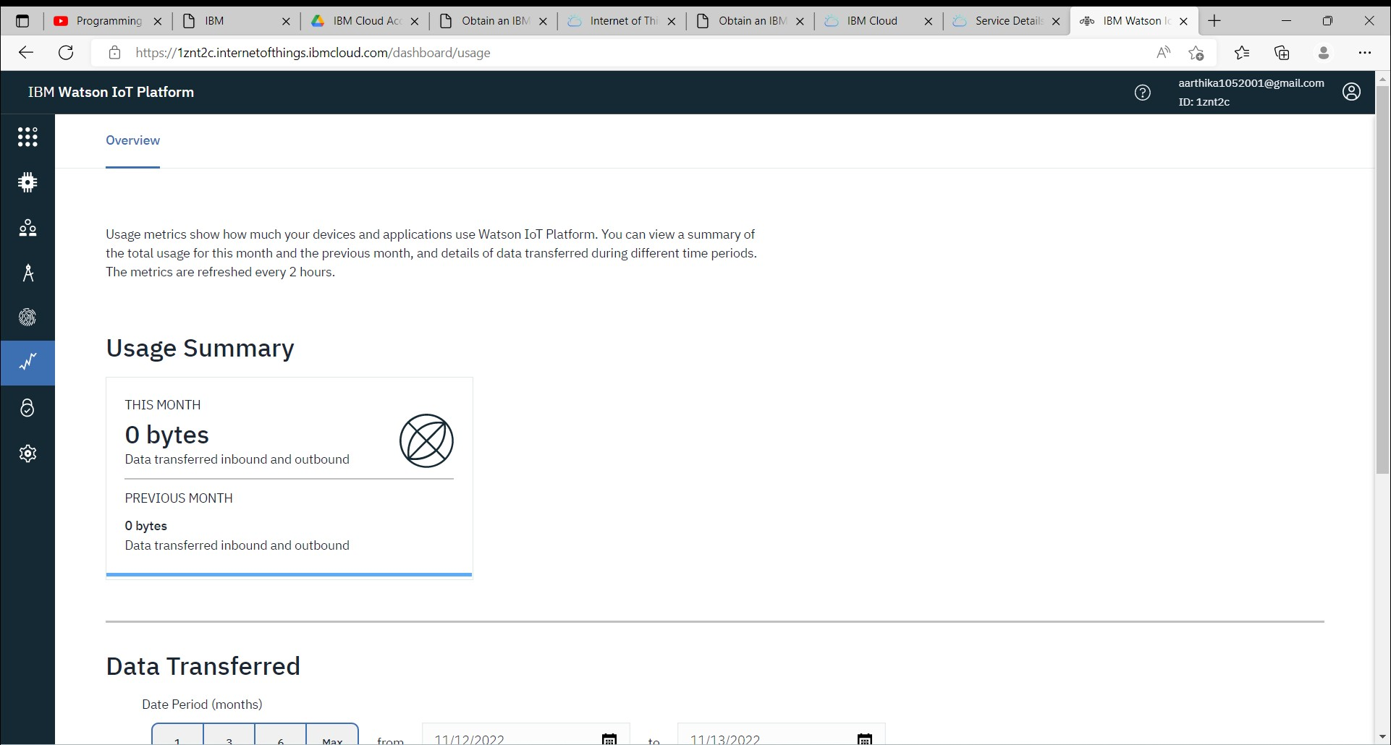

STEP12: This tab is used when you want to connect to some other platform and to integrate with other services

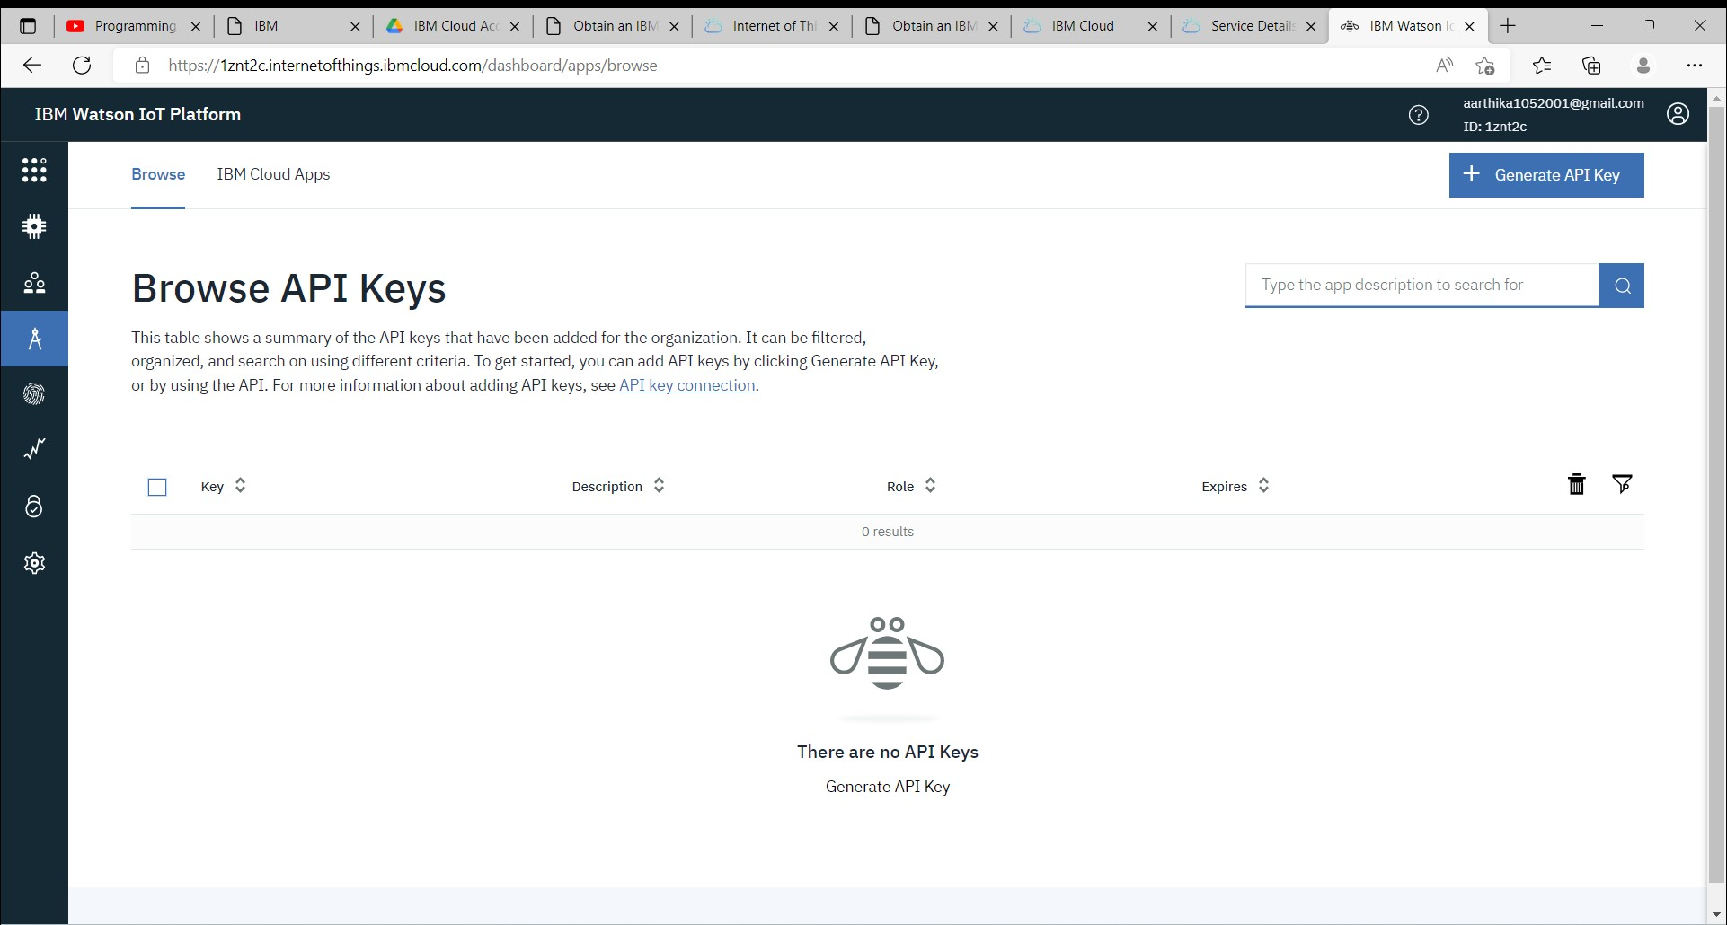

# STEP13: Click on the device tab and click on the add device button, then give the device type and device id and click next

STEP14: The Boards will display card for the project

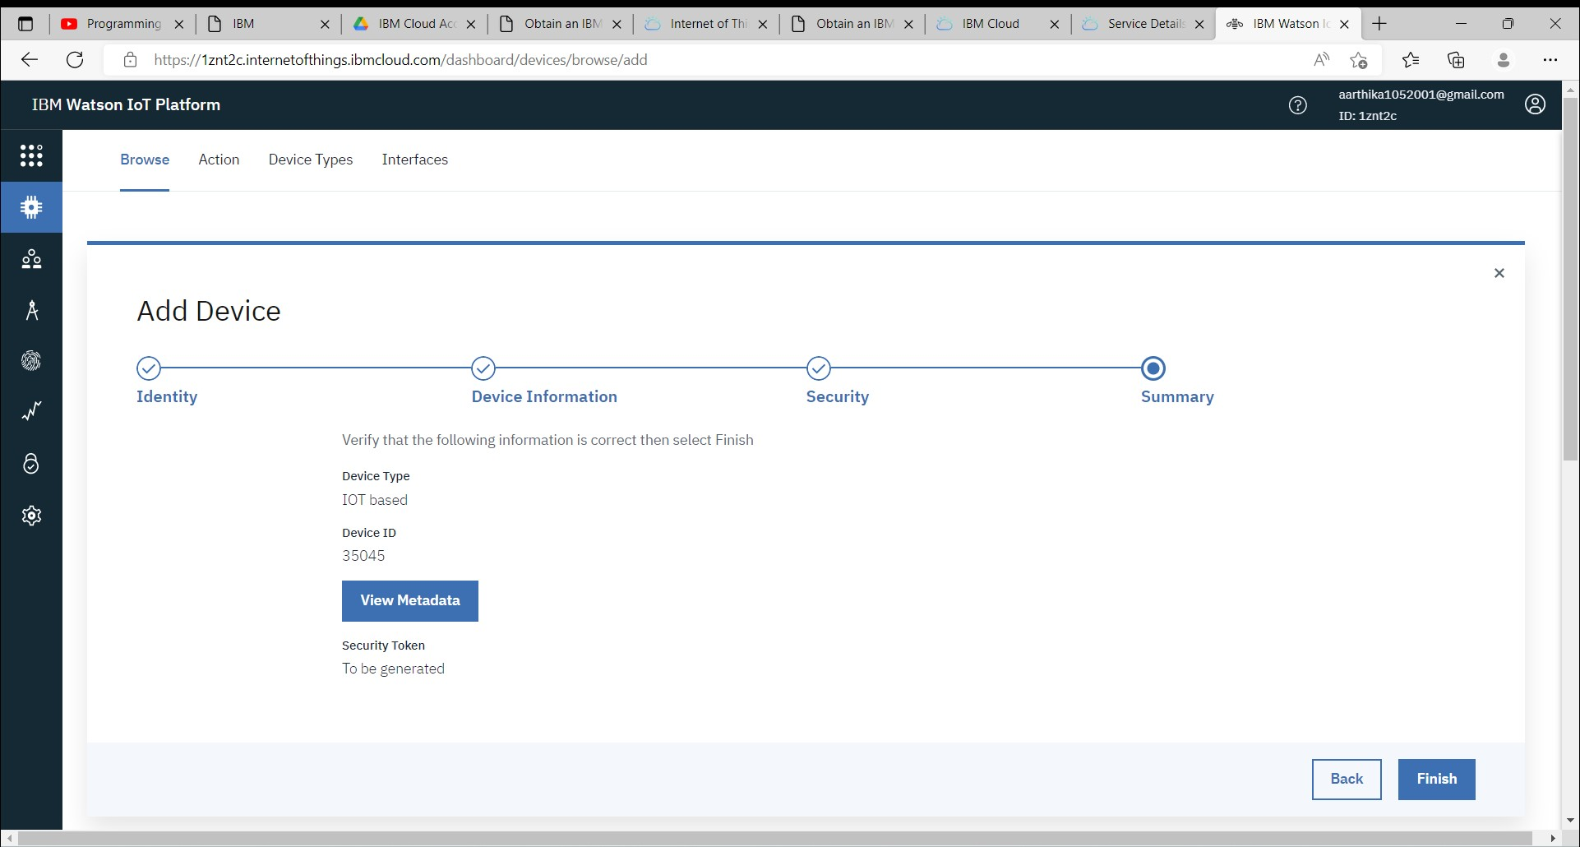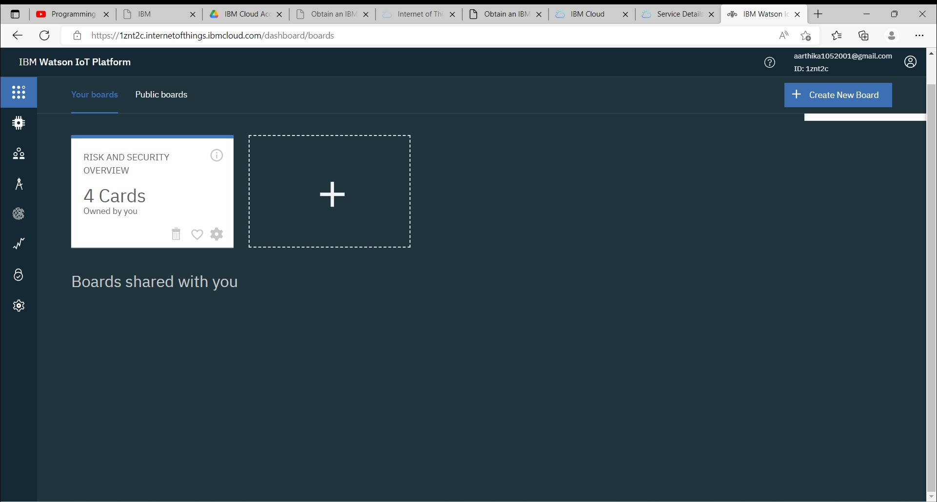

CONCLUSION:

An IBM Watson cloud for IOT and a device is created.

